Data architecture and management designer

1. sales users are complaining that report time-outs.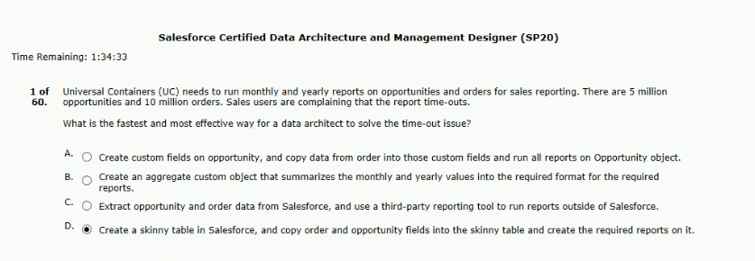
2. including and longitude in a custom object.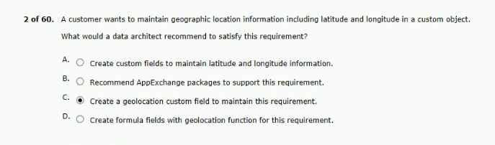
3.throwing a time-out error.
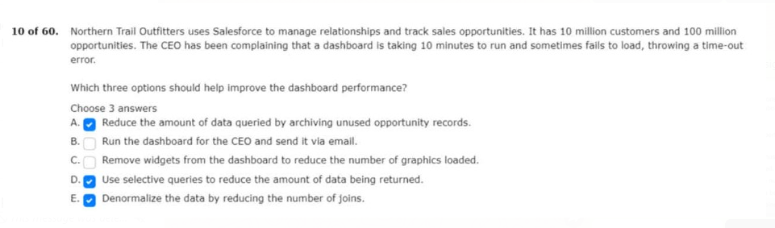

4.decided to categorize each data element in salesforce with the following: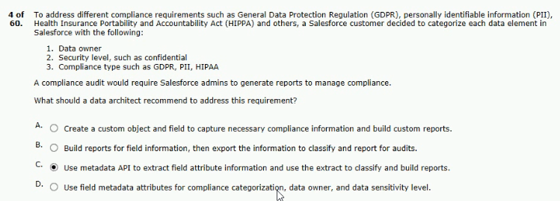
5.the following actors are in salesforce:
map the actors to salesforce object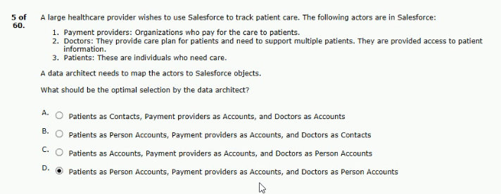
6.as part of its master data management strategy.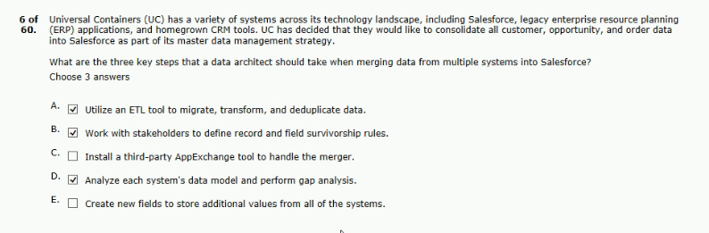
7.currently maintained in the following systems: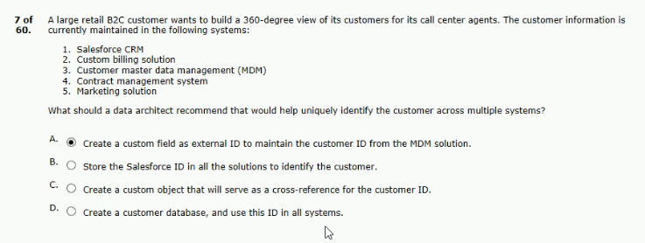
8.for users when they enter information in a standard field?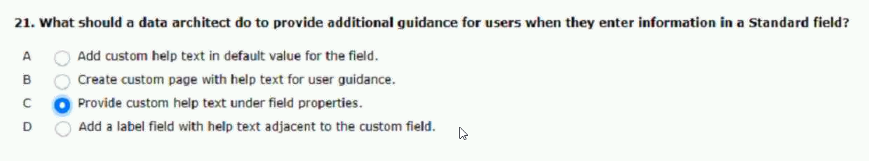
9.products and provide subscription (fee)-based support.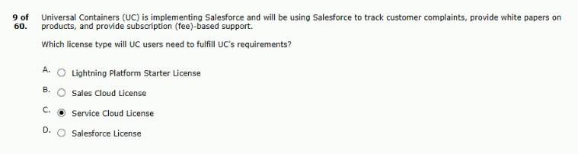
10.for backup within a version control system.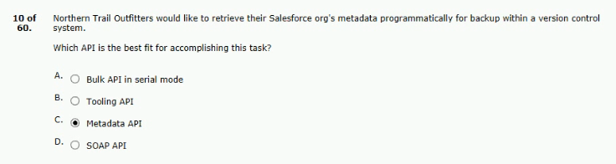
11.is concerned about the performance of the application.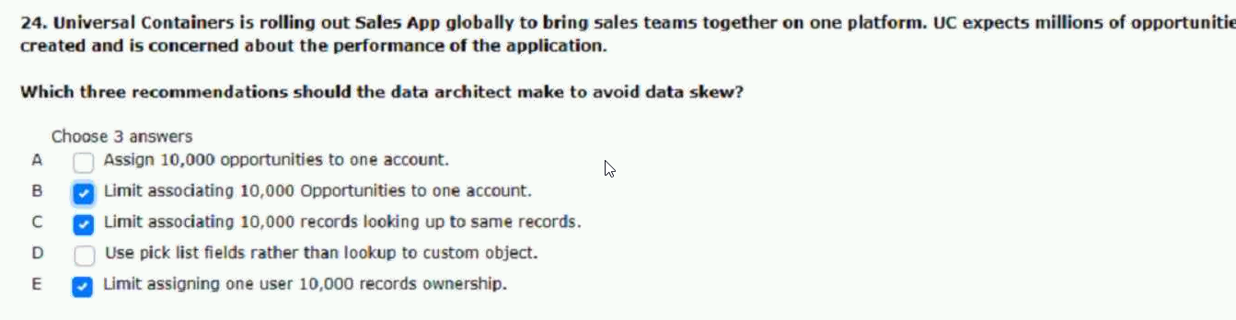
12.during this process the validation rules are disabled.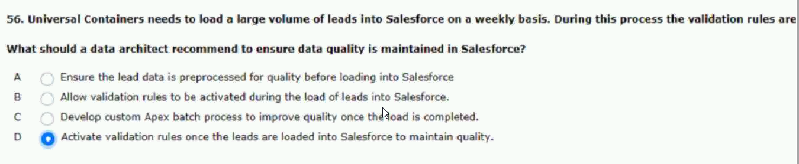

13.demand to service agents uc creates 5 millions cases per year.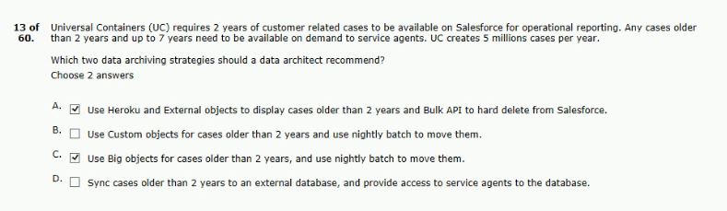
14.to preserve the following information on records being migrated:
data timestamps and ownership on records?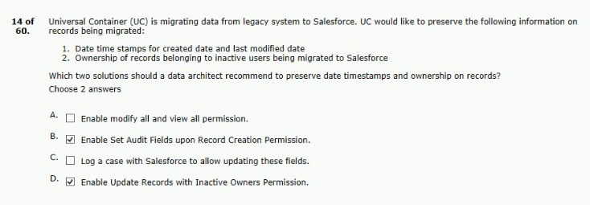
15.like to encrypt sensitive records being stored in files.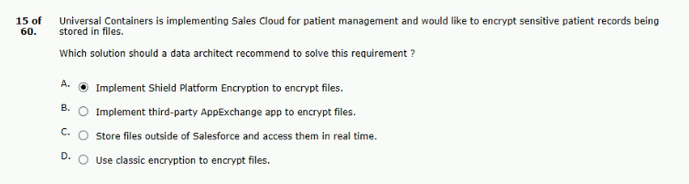
16.have access to historical cases for up to seven years.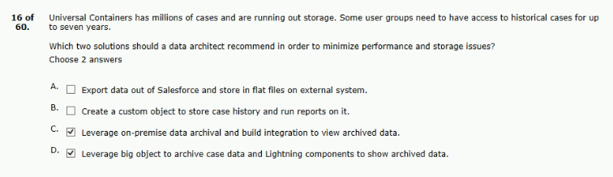

have access to historical cases for up to seven years.
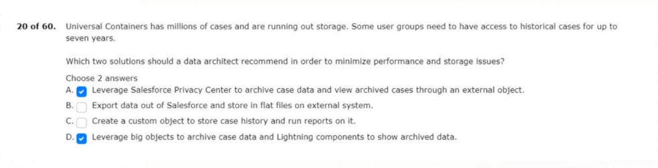
17.historical records and is currently not integrated with salesforce.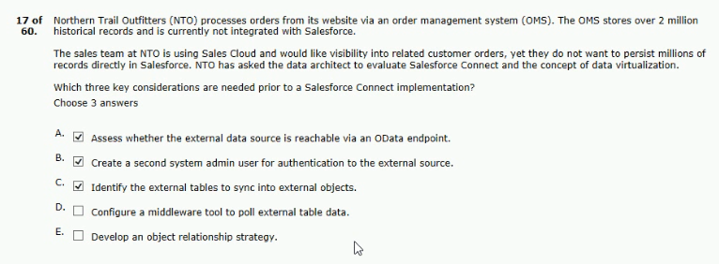
18.the opportunity management in salesforce is implemented as follows:
when pps updates their opportunities.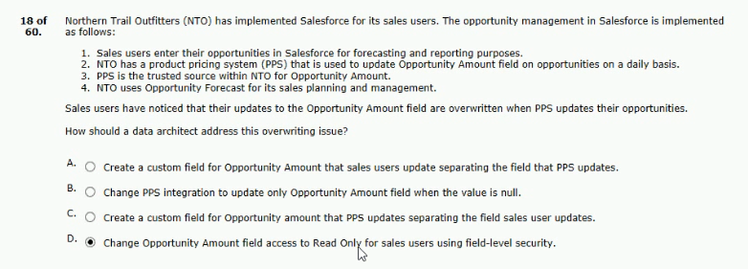
19.and would like to monitor and measure data quality.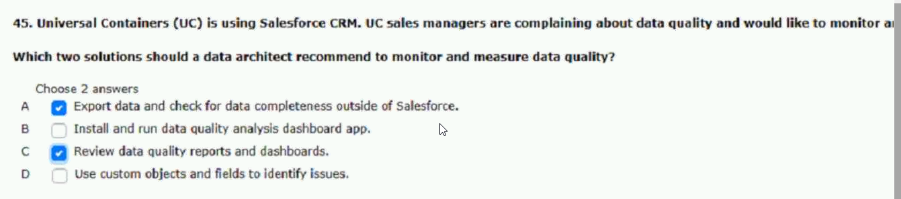
20.query time-out issues while extracting these records.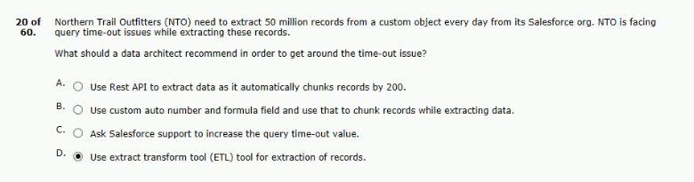
21.pain point that there are multiple versions of many customers.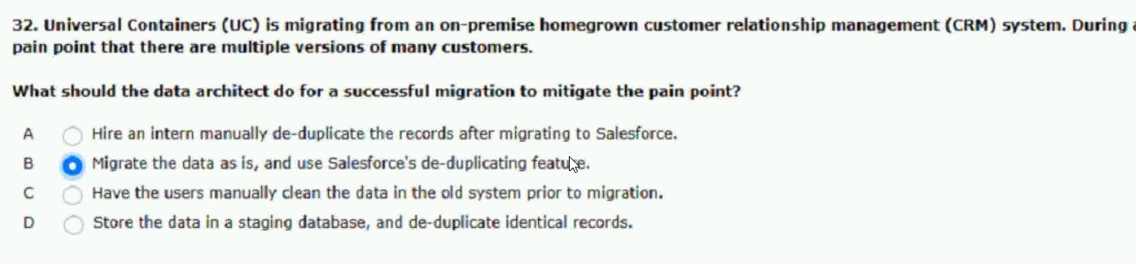
22.needs a sales model that allows the following:
sales is aggregated by sales area for reporting.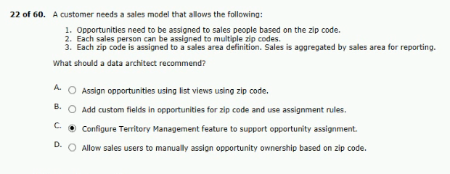
23.so that salesforce can now act as the system of record.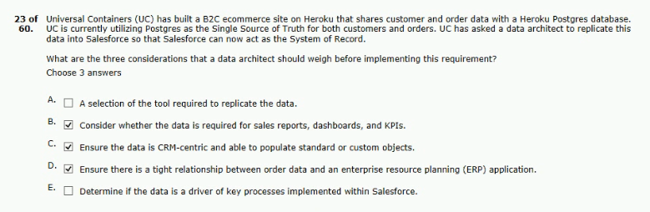
24.the cloud provider;s built-in data recovery solution.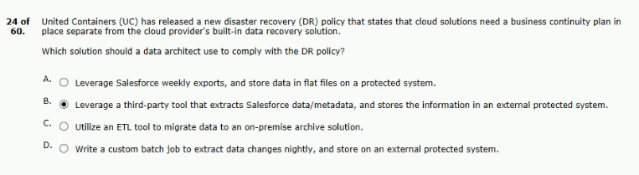
25.being exported as part of the data export.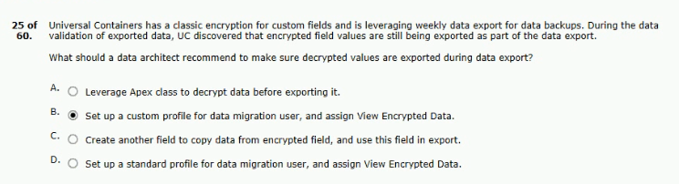
26.profiles and location information.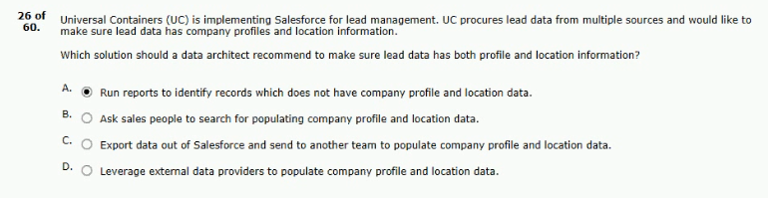
27.is experiencing lock errors consistently.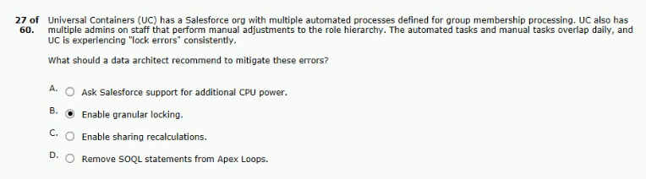
28.allow customers to classify in salesforce.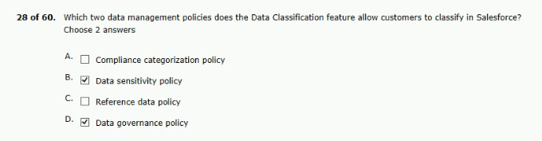
29.for 10 years for audit purpose.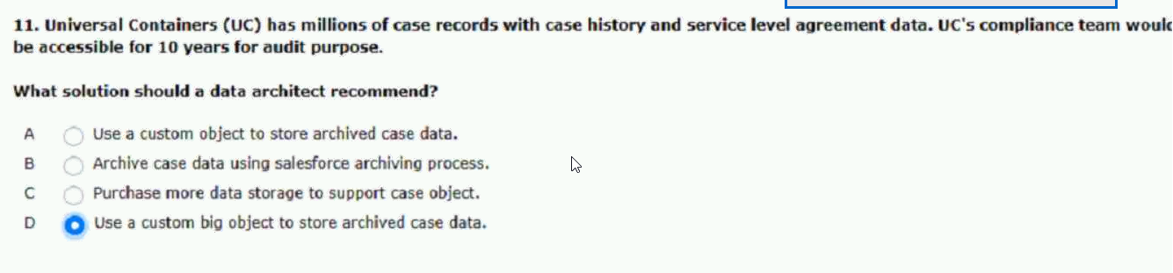
30.well as view the reports in dashboards.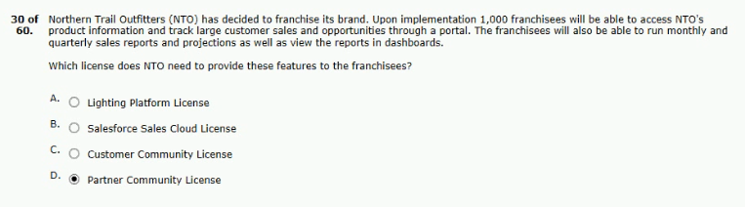
31.is concerned about storage limitations.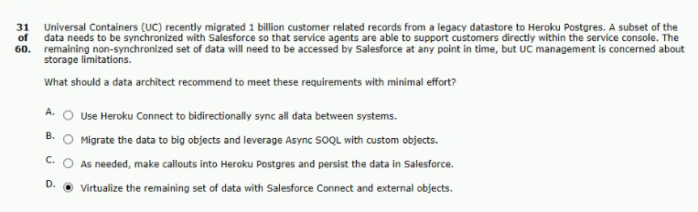
32.needs to be migrated to salesforce.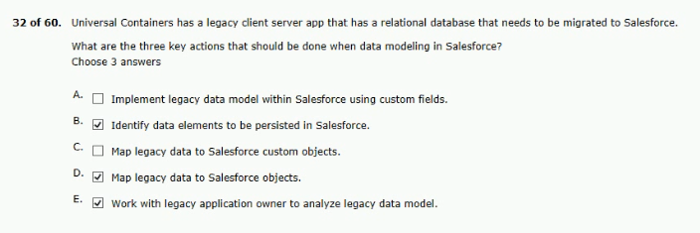
33.history and relevance of its customer data.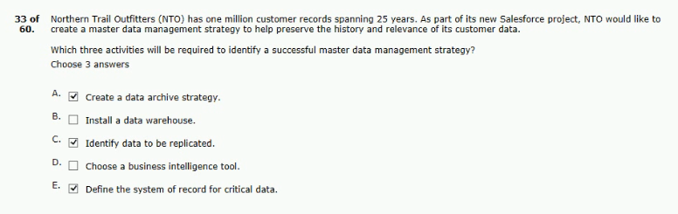
34.ownership skew and performances.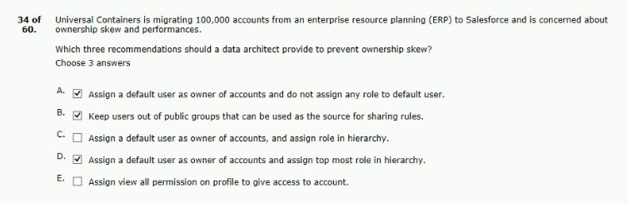
35.to load and returns a time-out error.

36.around reporting on the migrated data.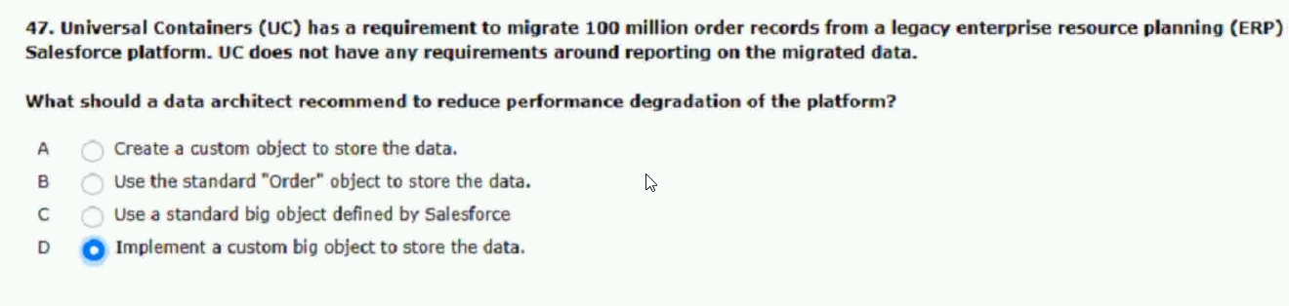
37.orgs after the products are approved.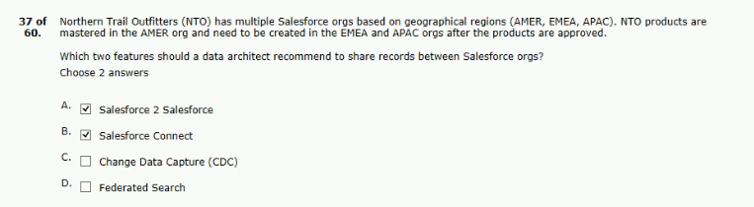
38.not have a value in the whatID field: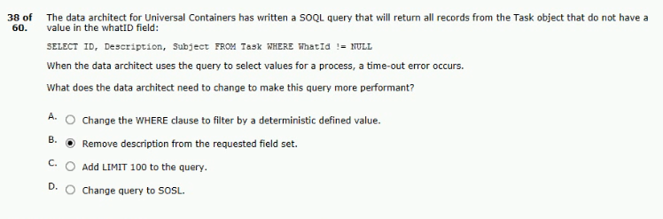
39.the following conditions exist:
they have attained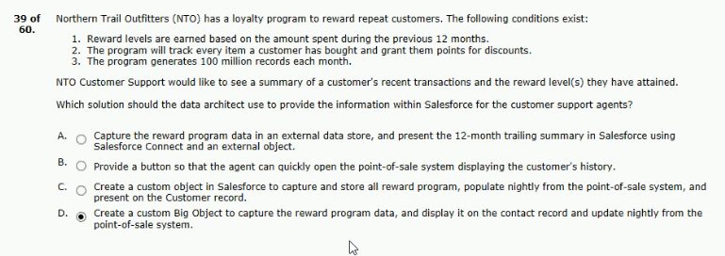
40.when viewing customer and account list views.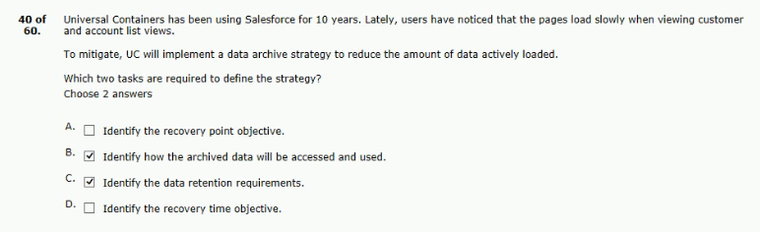
41.systems that record customer activity: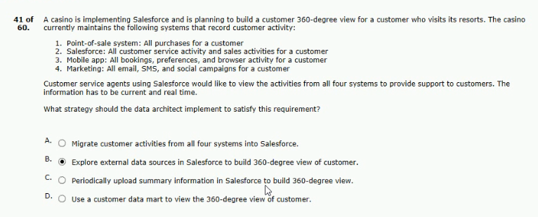
42.they have the following record counts:
slow response for reports and list views.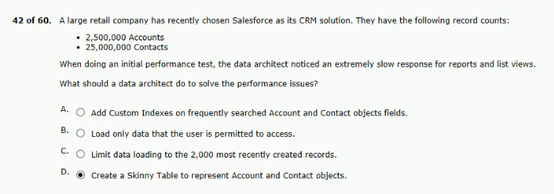

43.portal with the following requirements:
to meet the portal requirements.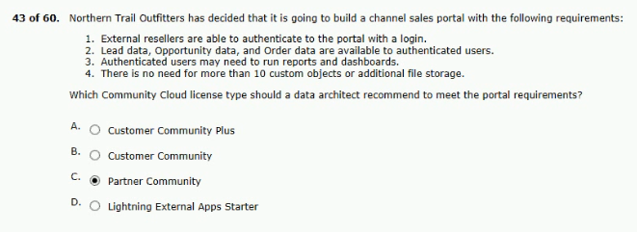
44.to analyze and define data quality standards.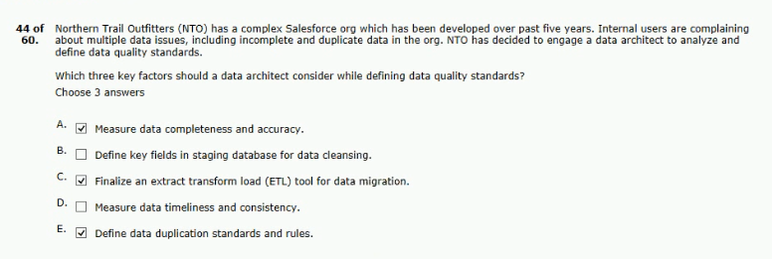
45.salesforce, includes the following:
and details monitoring of user activity.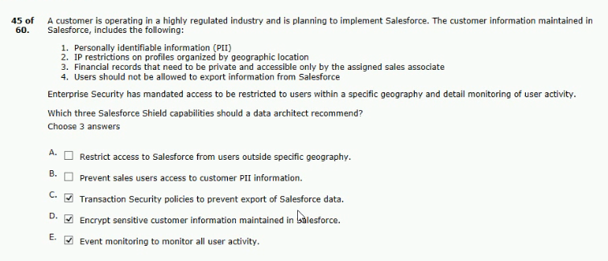
46.unable to view customer across all orgs.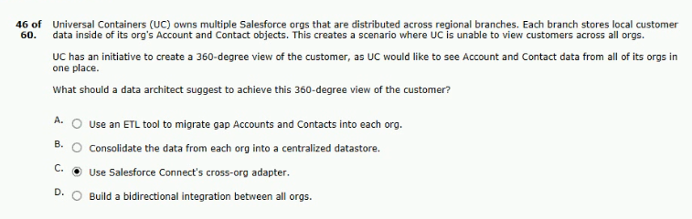
47.share opportunities between orgs in near-real time.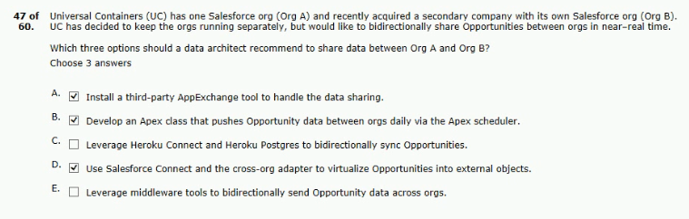
48.of order inside salesforce.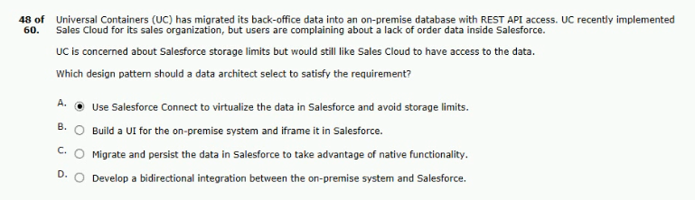
49.stores are also created in salesforce as accounts.
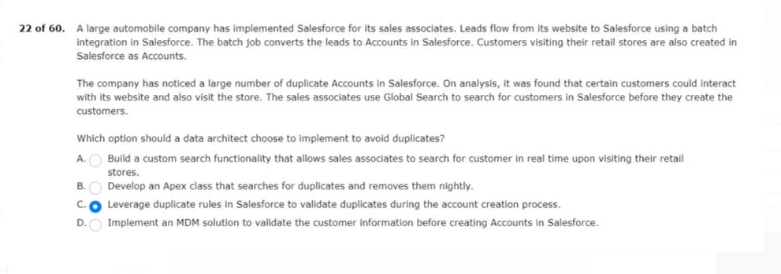

50.data including user data in a timely manner.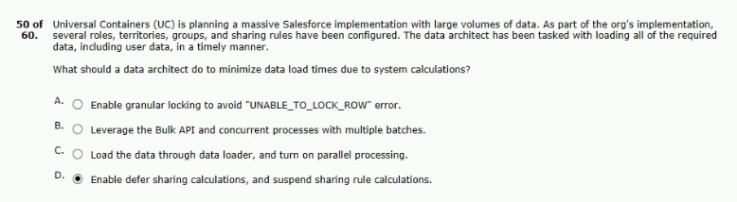
51.is throwing an unable to lock a row error?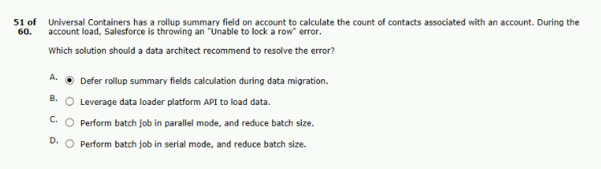

52.has the following systems:
of truth for the customer records.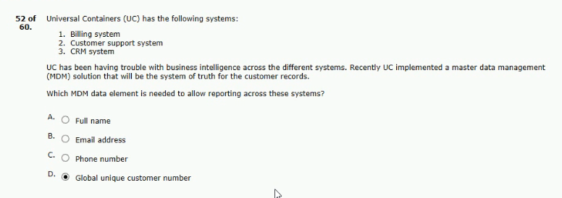
53.should be maintained in the target org.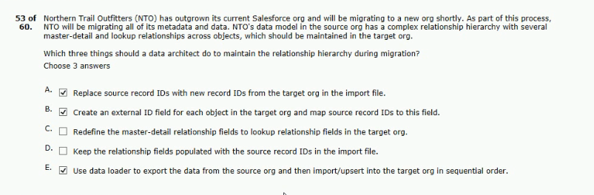
54.that they have attended with the following requirements.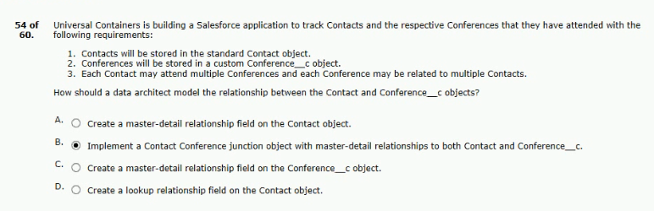
55.data management (MDM) solution with these attributes:
single source of truth.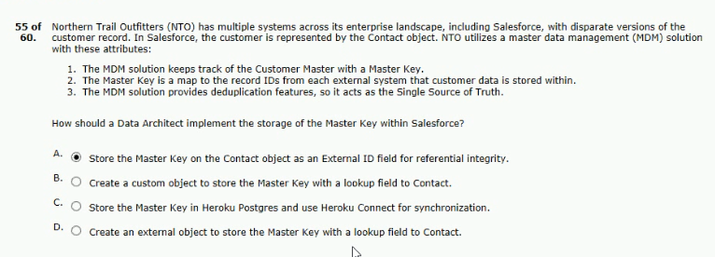
56.all orders are assigned to a generic user.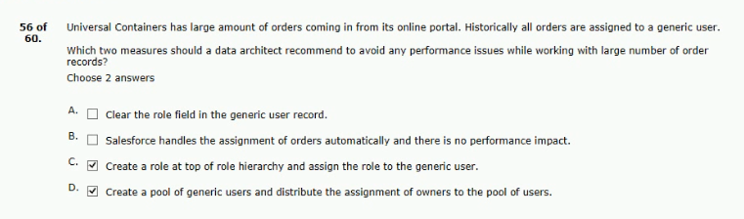
57.the contact information stored in salesforce.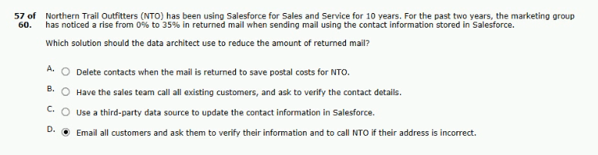
58.store customer information including salesforce.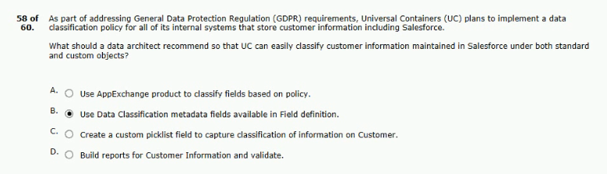
59.and contacts in the legacy database.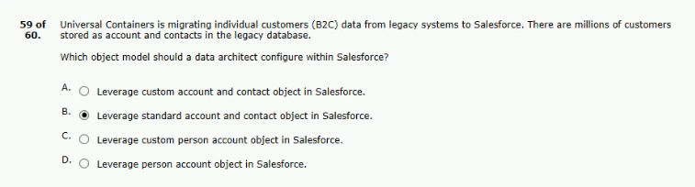
60.have access to its child opportunity record.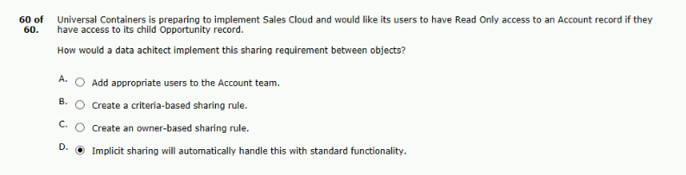

61.the following actors are in salesforce:
who need care.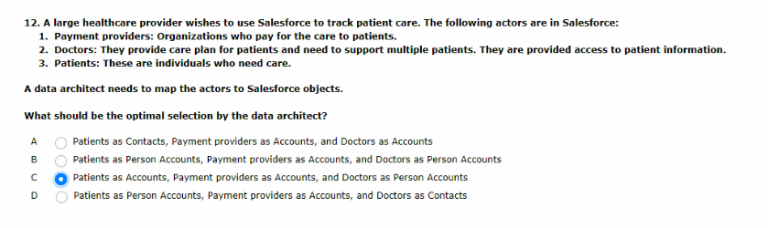

62.has the following system:
call in to update their information.
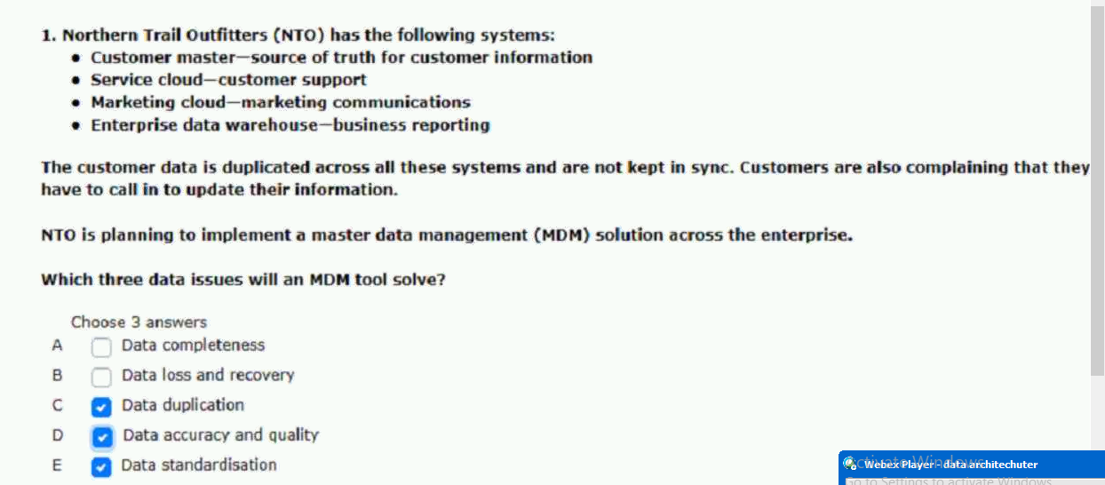

63.fails to load throwing a time-out error.

64.latitude and longitude in a custom object.
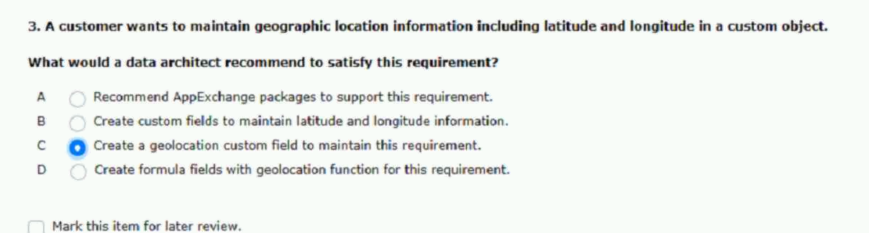
65.automated updates at the same time.
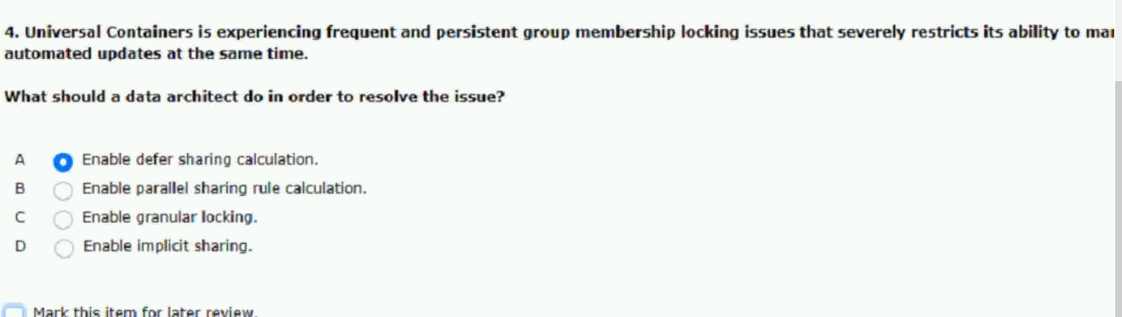

66.the following conditions exist:
reward level(s) they have attained.
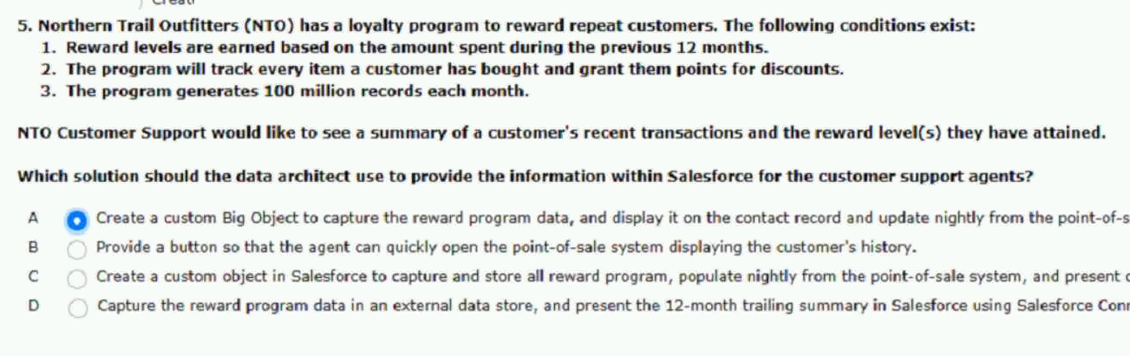
67.these requirements to its data architect:
next two months prior to the spilt.
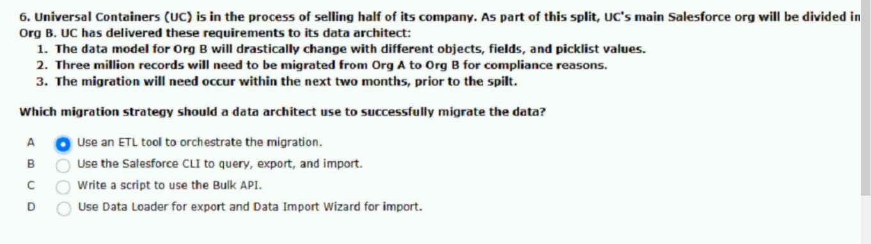
68.making changes to salesforce.
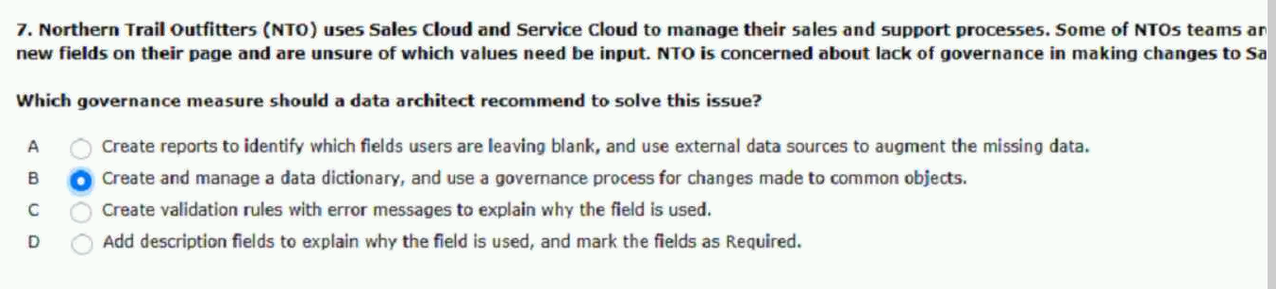

69.the agent relationship in a look-up table
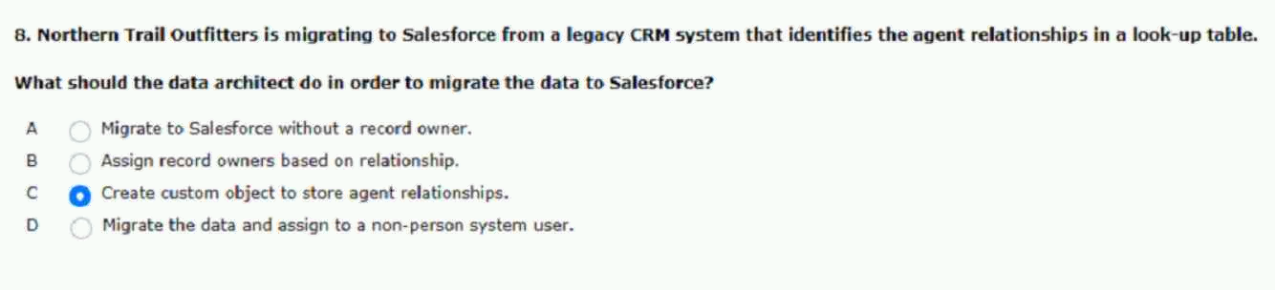

70.opportunity record.
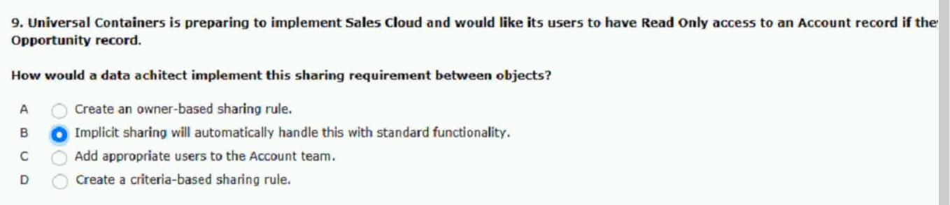
71.throwing an unable to lock a row error.
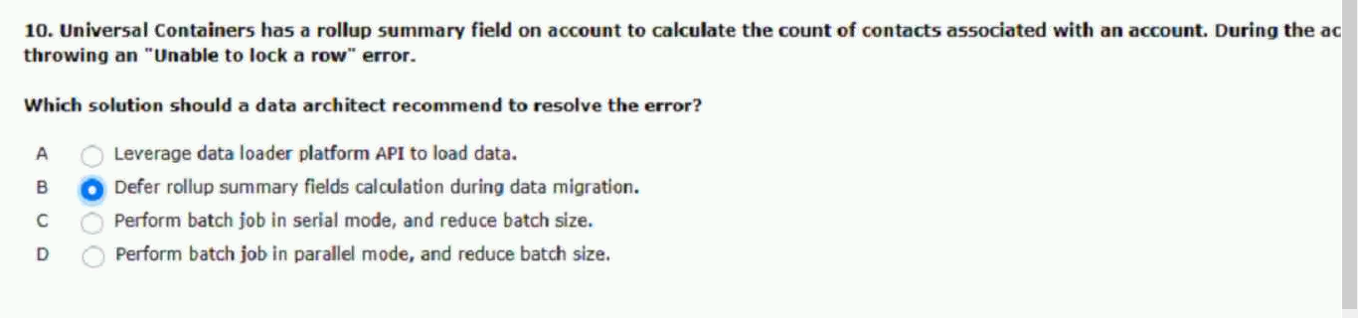

72.has the following systems:
system of truth for the customer records.
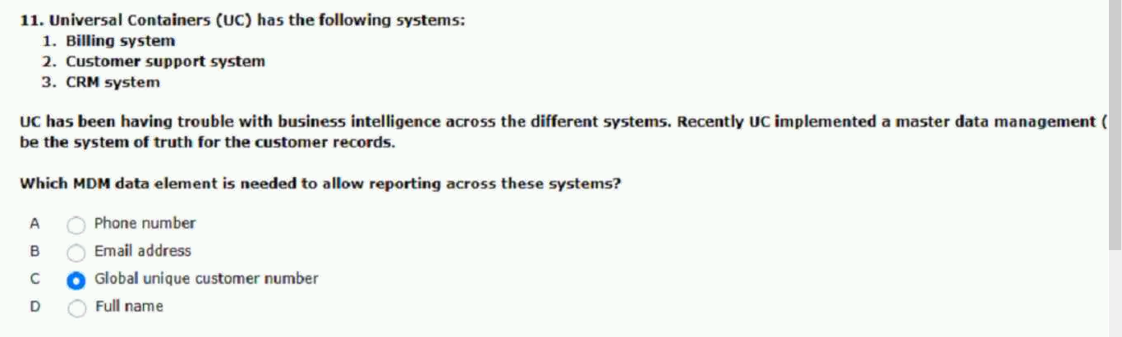
73.lock errors consistently
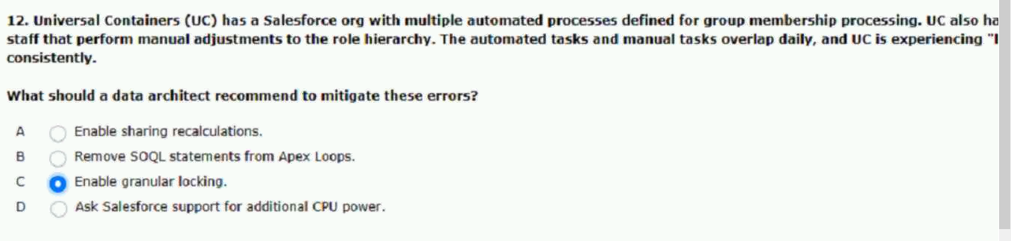
74.leads opportunities to the next stage.
across 10 to 15 external objects.
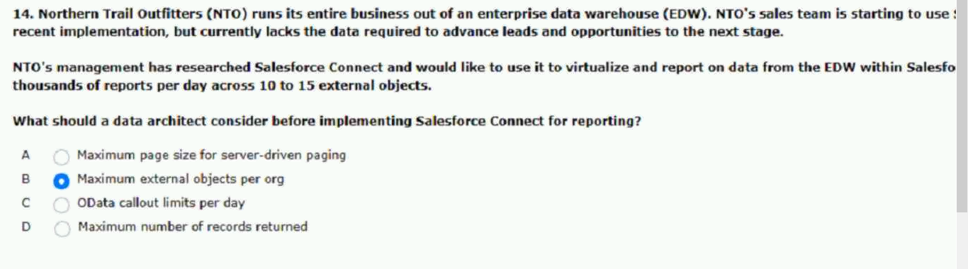

75.the following conditions exist:
in multiple quotes and opportunities.
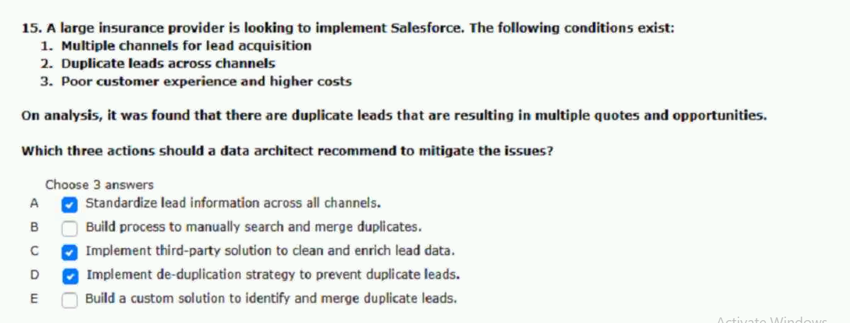
76.across several objects over the weekend.
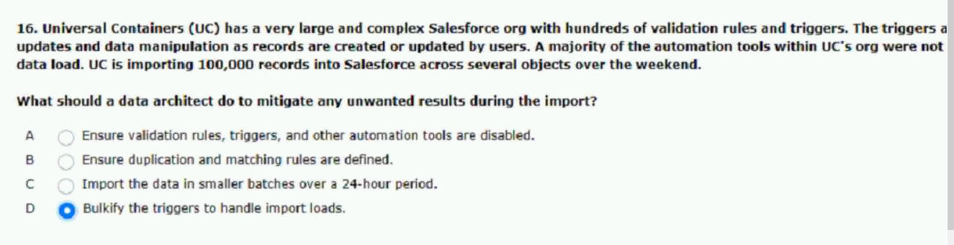

77.About ownership skew and performances.
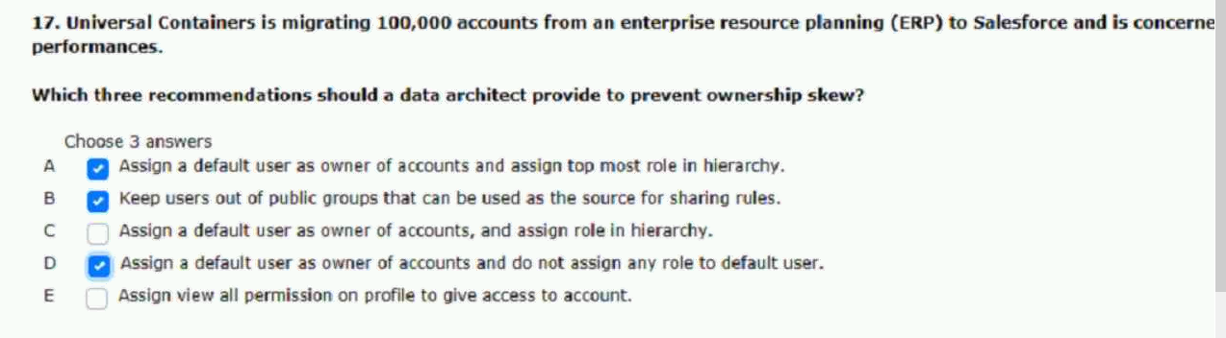

78.also created in salesforce as accounts.
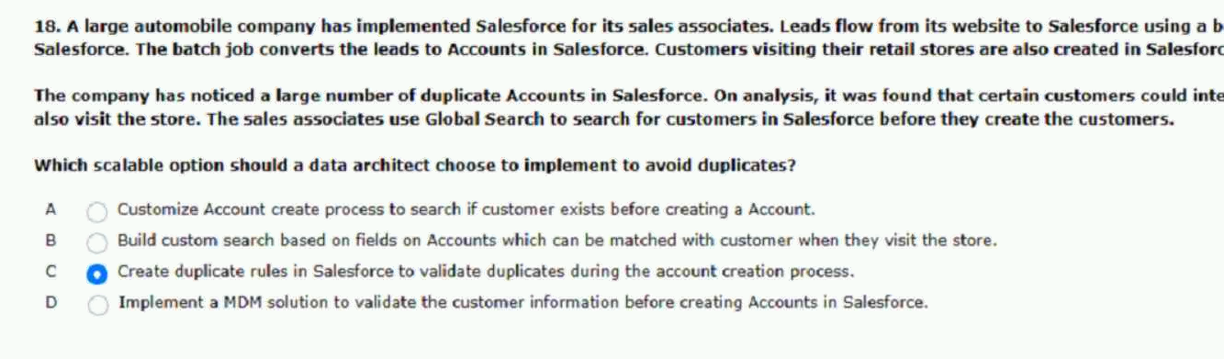
79.users and through external integrations.
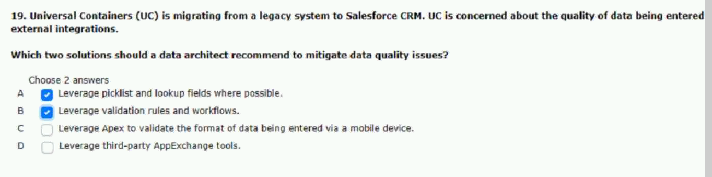

80.households, businesses, and individuals.
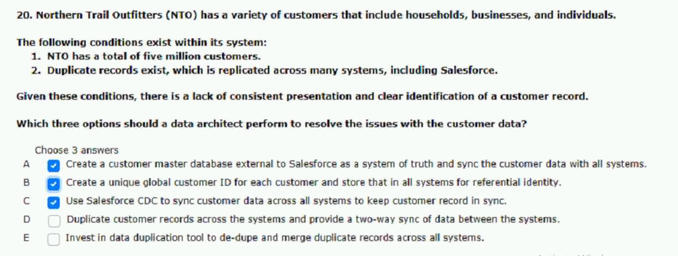

81.with data entered in salesforce:
cause incorrect counts.
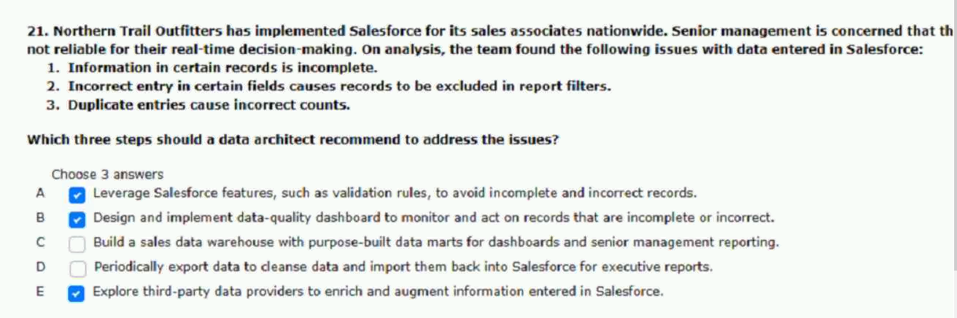

82.deduplicate data before migrating to salesforce.
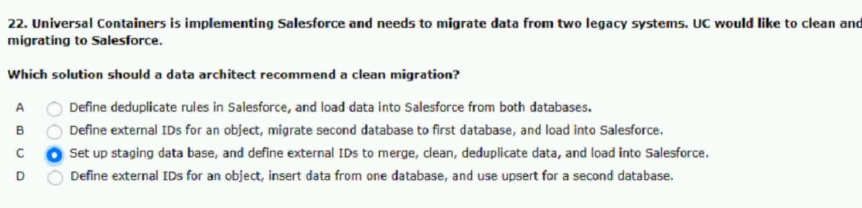
83.following system:
the customer across multiple systems?
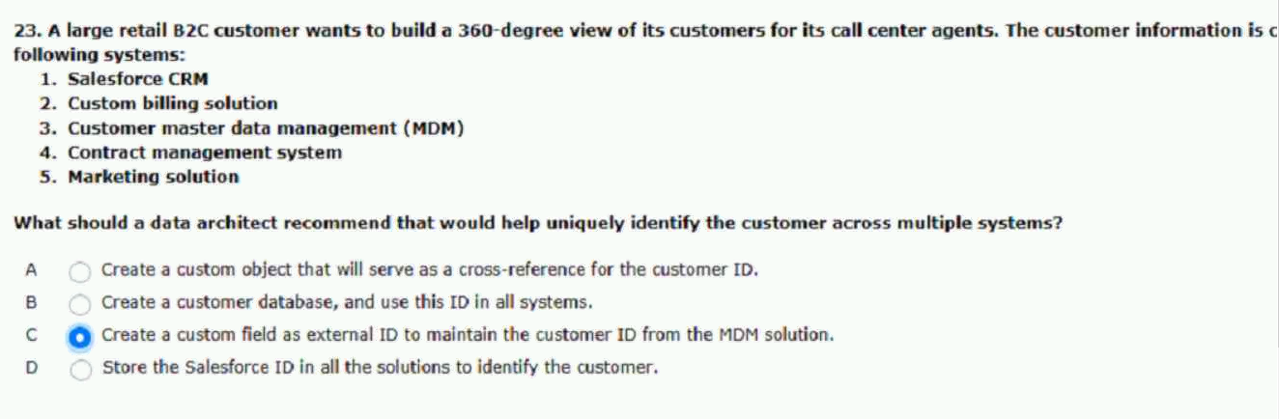
84.salesforce connect is needed.
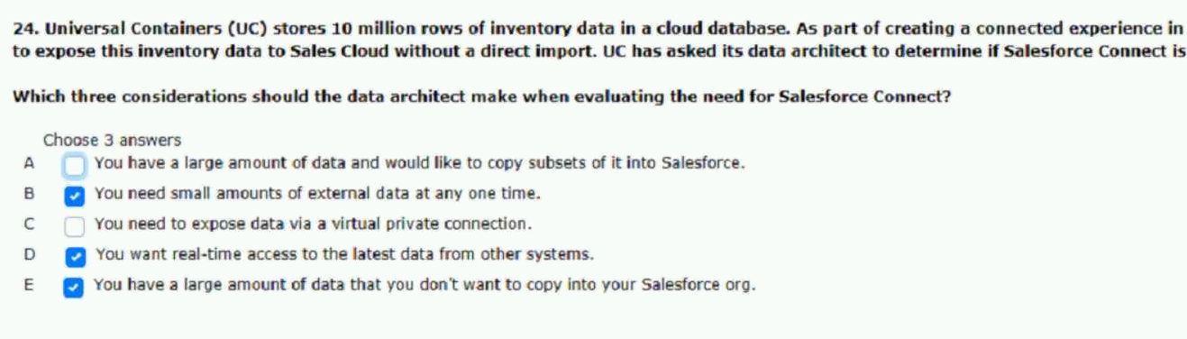

85.in a timely manner.
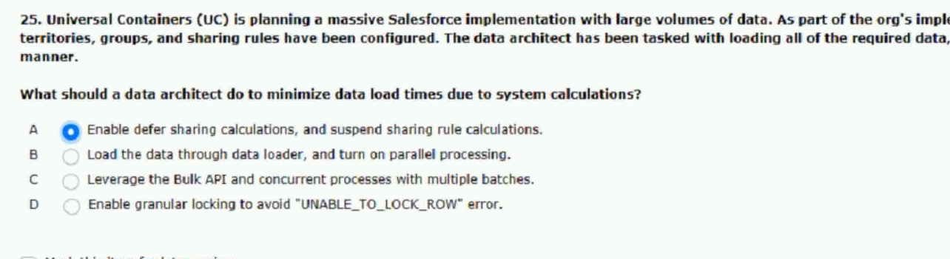
86.systems that record customer activity.
and real time.
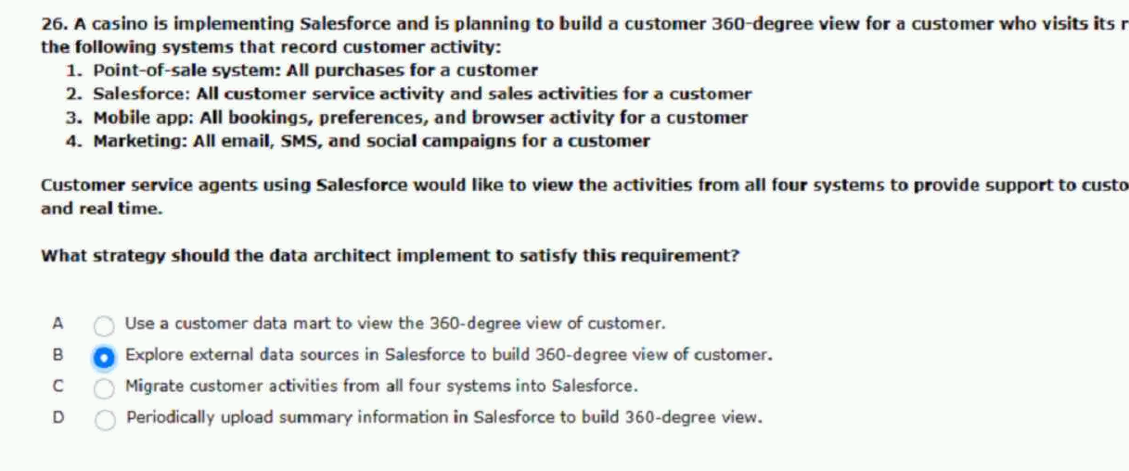
87.custom fields need to encrypted.
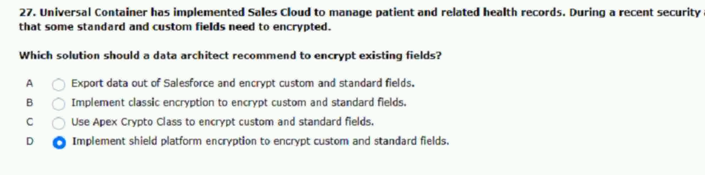

88.load and returns a time-out-error.
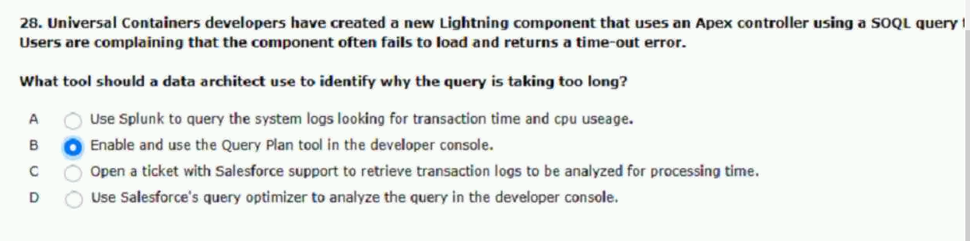
89.validation rules are disabled.
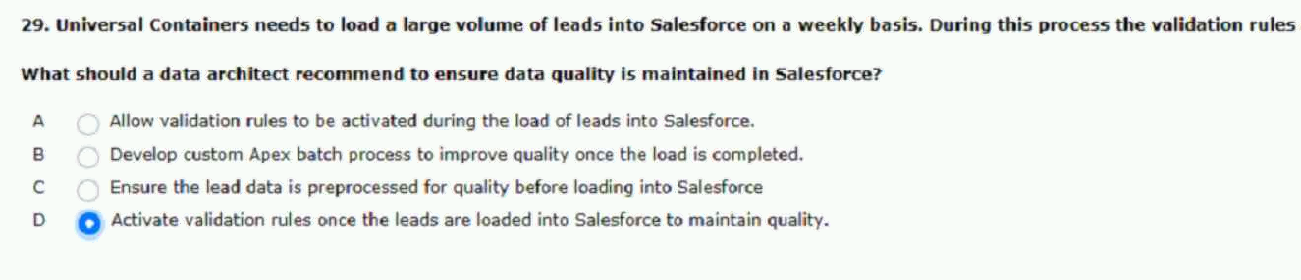
90.when registering for an account.
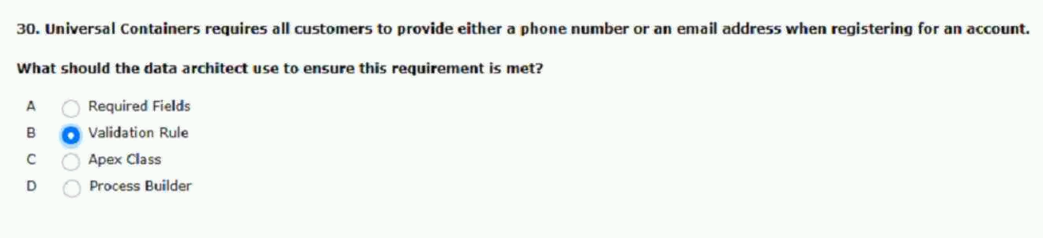
91.information stored in salesforce.
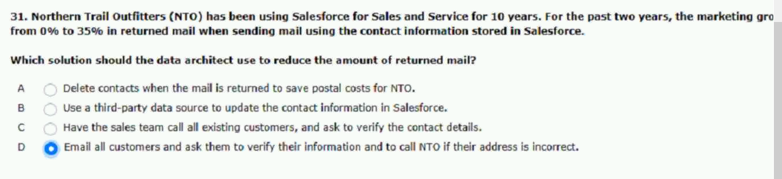

92. support this business requirement.
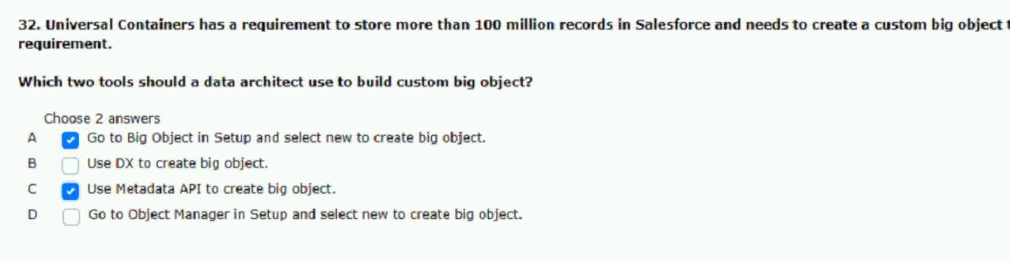
93.on this asset data weekly.
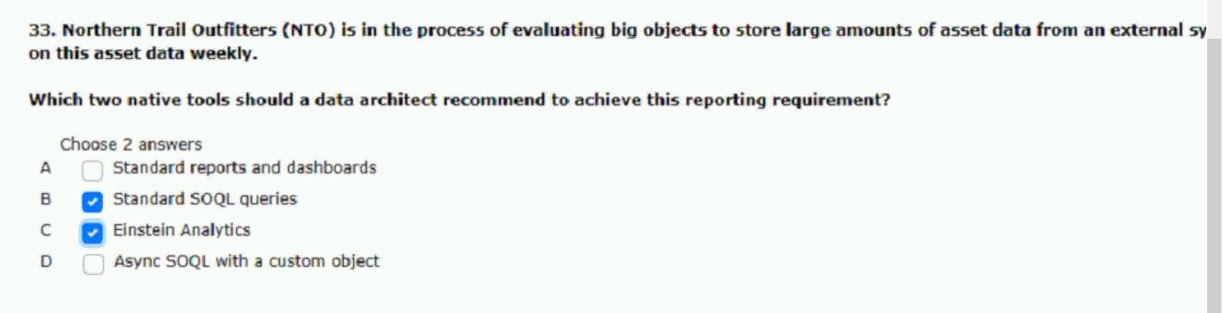
94.reports in the salesforce org.
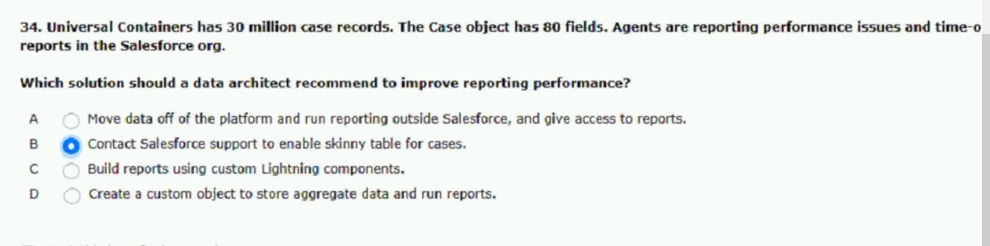

95.classic to lightning experience.
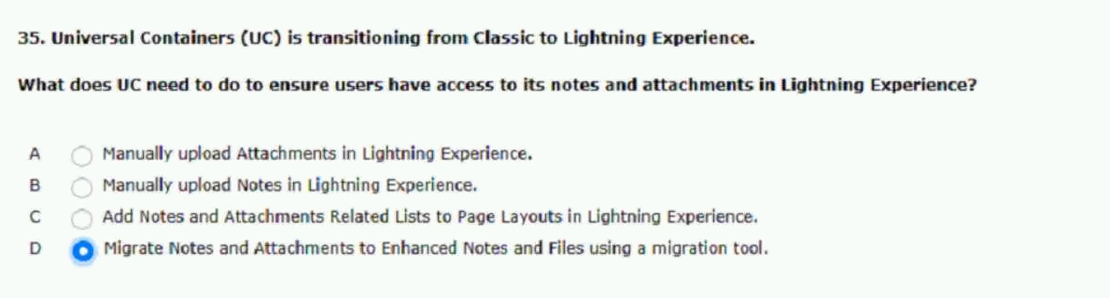
96.quality issues with account data.
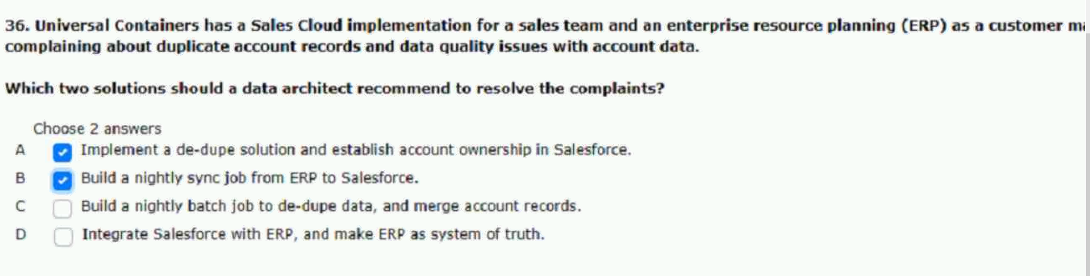
97.follwing requirements.
recommend in this scenario?
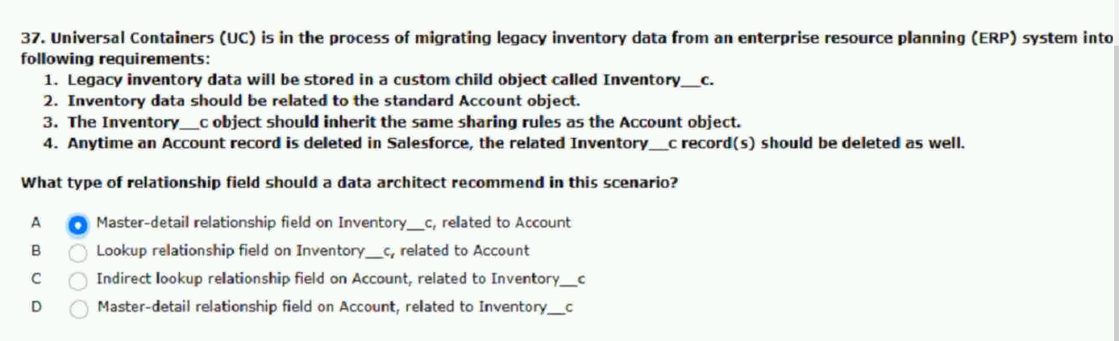

98.orgs in near-real time.
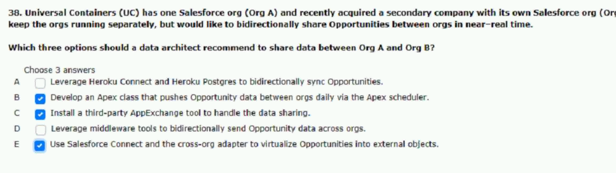
99.unused records from the org.
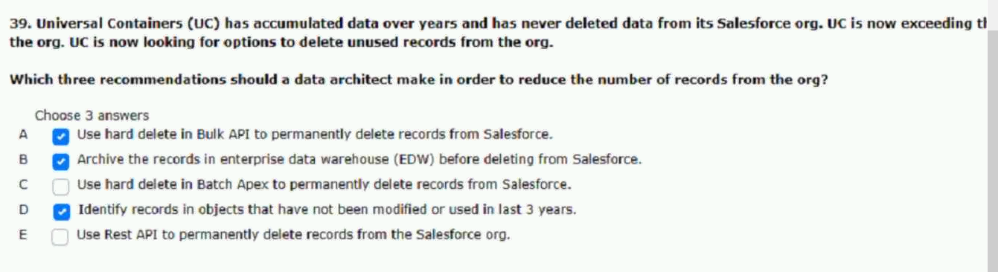
100.supporting a monthly billing cycle.
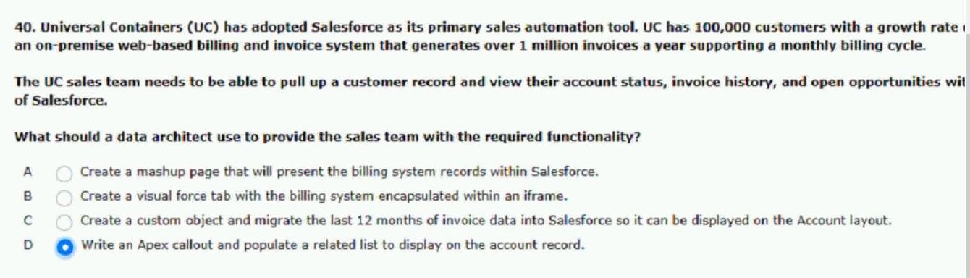

101.salesforce on an as needed basis.
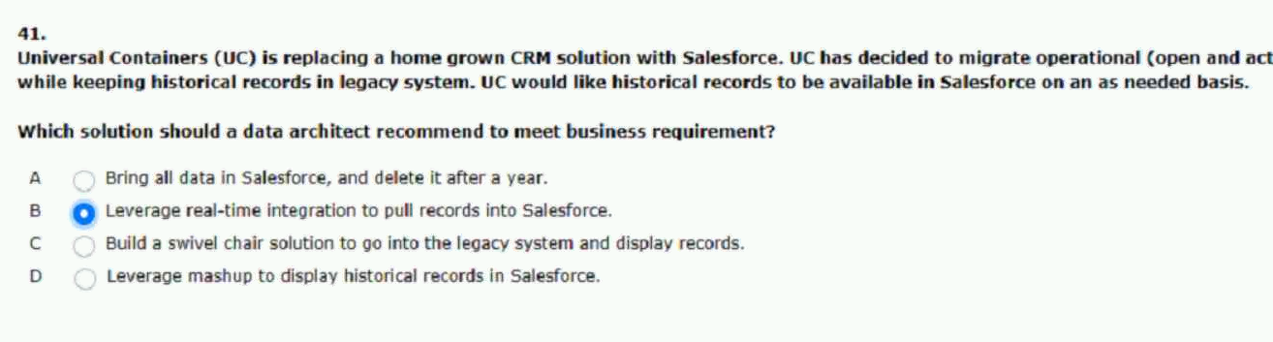
102. value in the whatidfield.
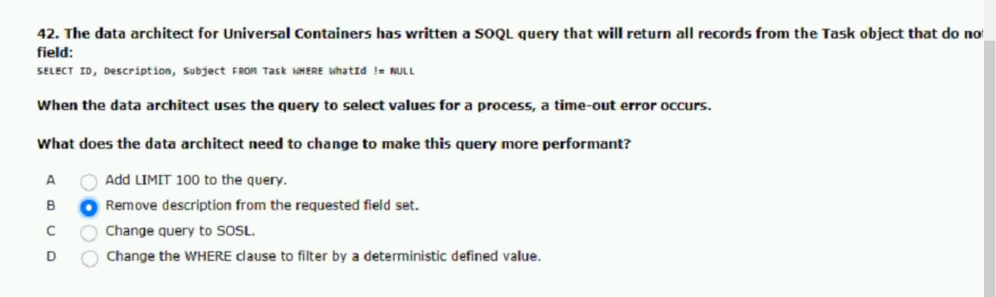
103.older data out of salesforce.
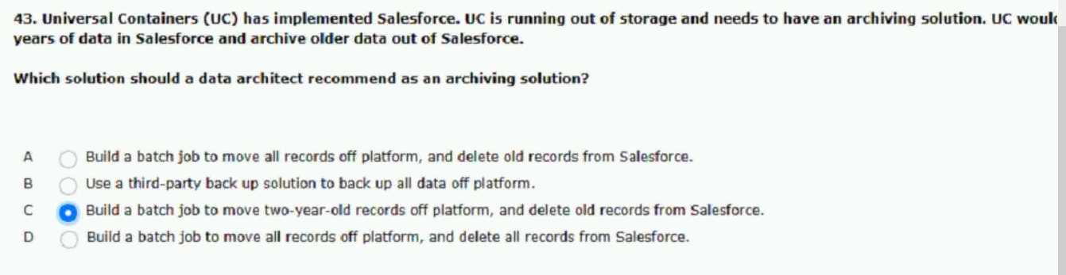

104.following salesforce products.
marketing process.
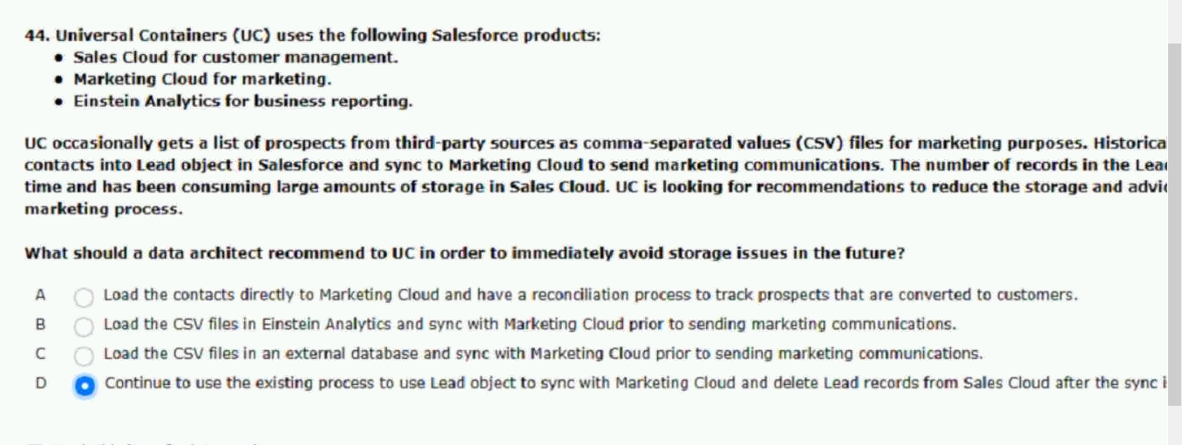
105.in salesforce includes the following
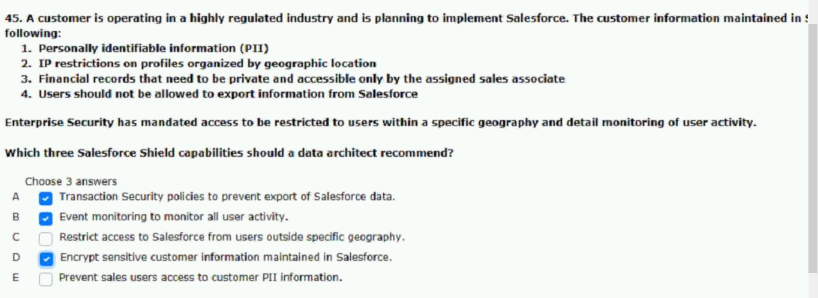
106.race conditions on the same record.
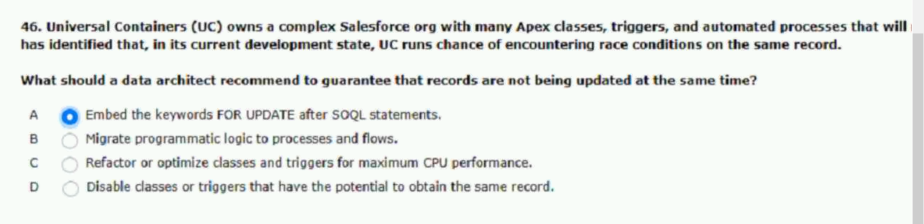

107.Data element in salesforce with the following.
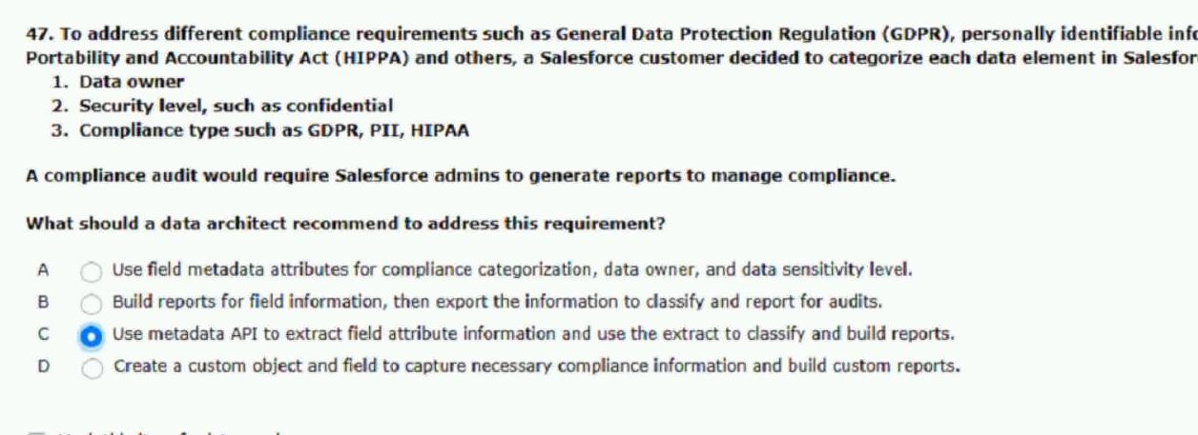
108.migration to the EDW.
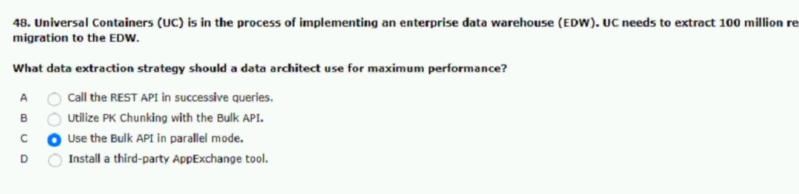
109.that needs to be migrated to salesforce.
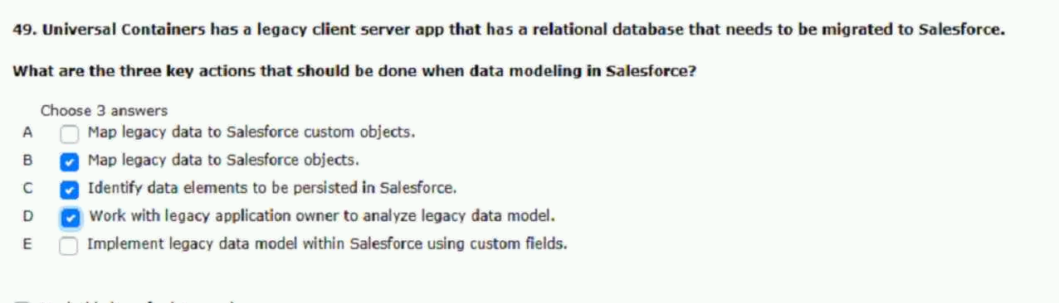

110.from an on-premise application daily.
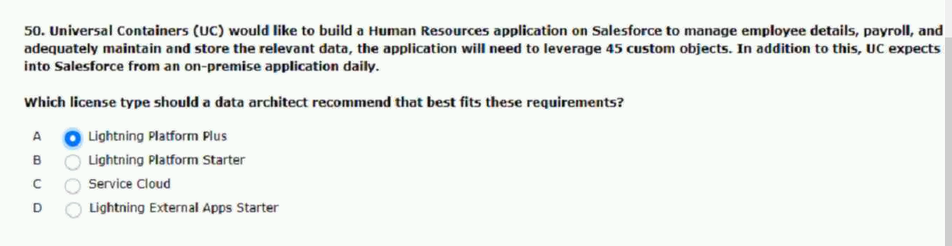
111.with the following hierarchy.
be built in salesforce?
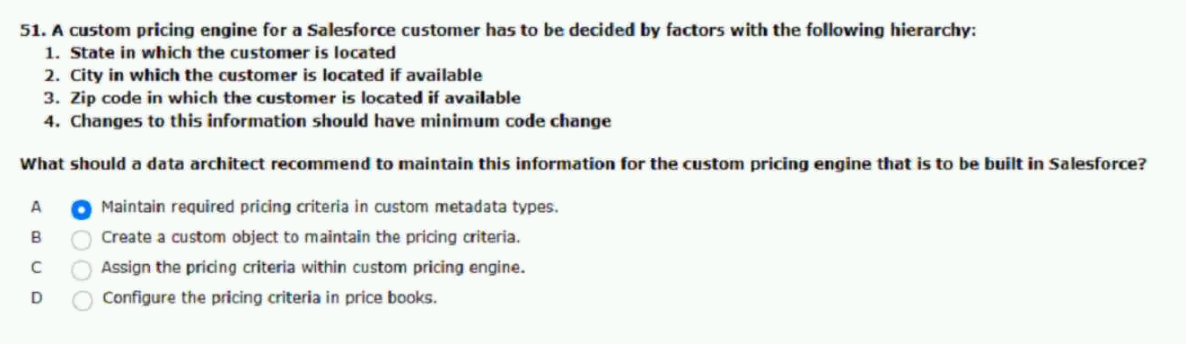
112.leading to data-visibility issues.
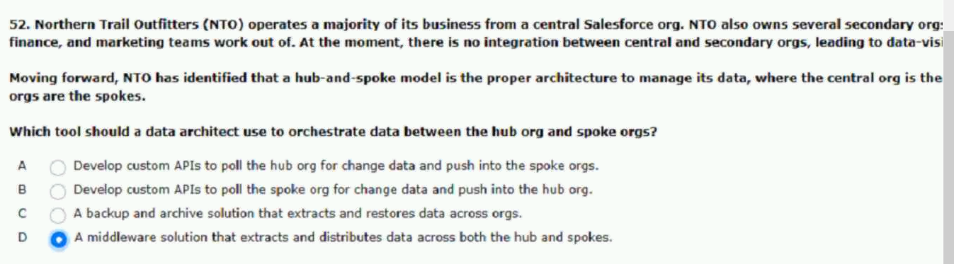

113.for sales order.
orders in salesforce?
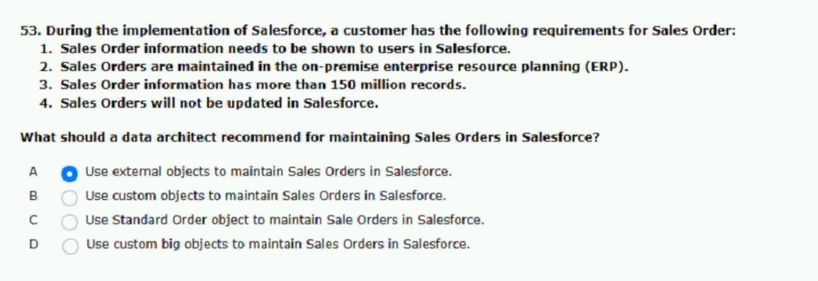
114.visibility into order status?
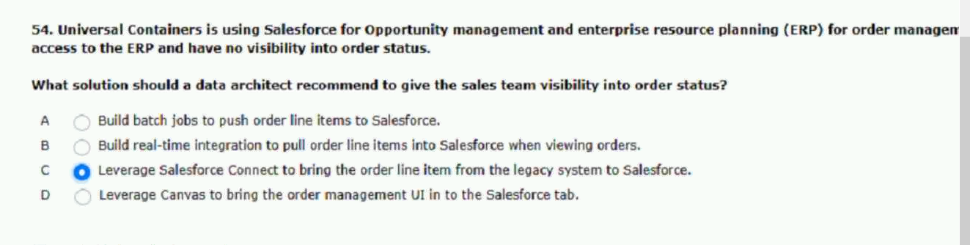
115.for a data export process.
these requirements?
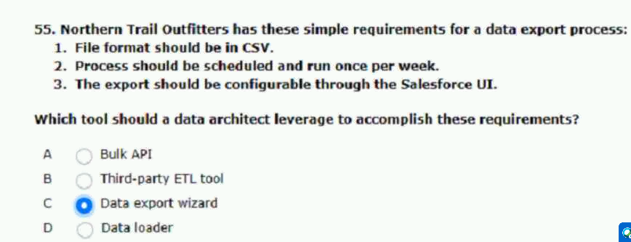

116.following record counts.
reports and list views.
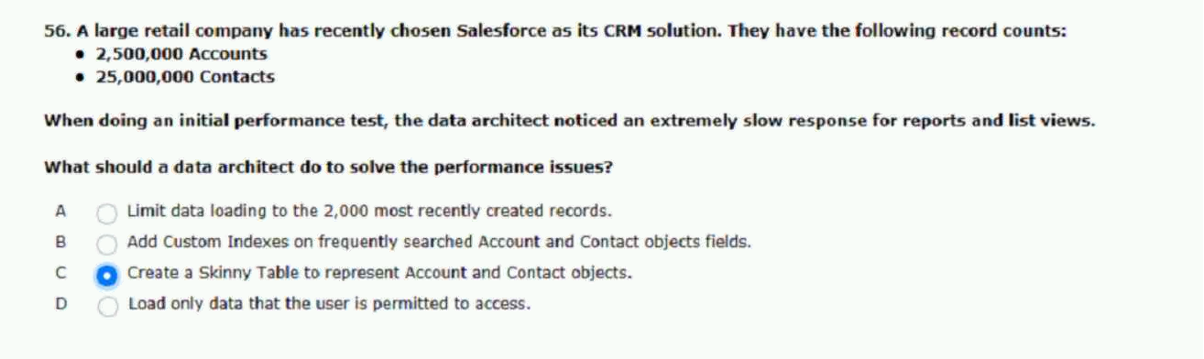
117.information including salesforce.
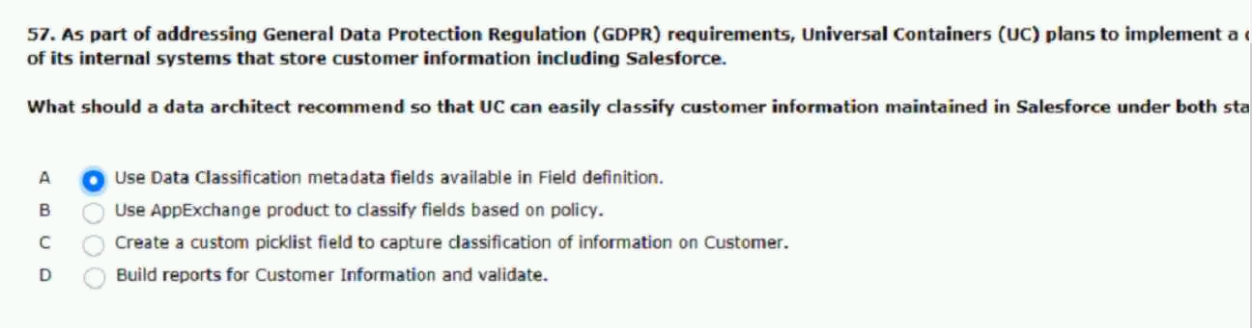

118.the application has the following capabilities.
orders in opportunities objects.
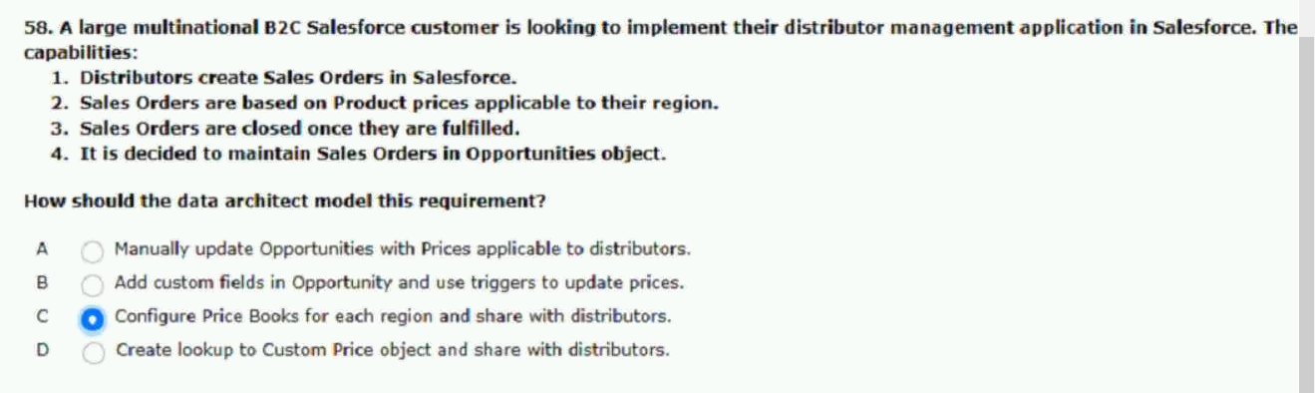

119.employee billable hours.
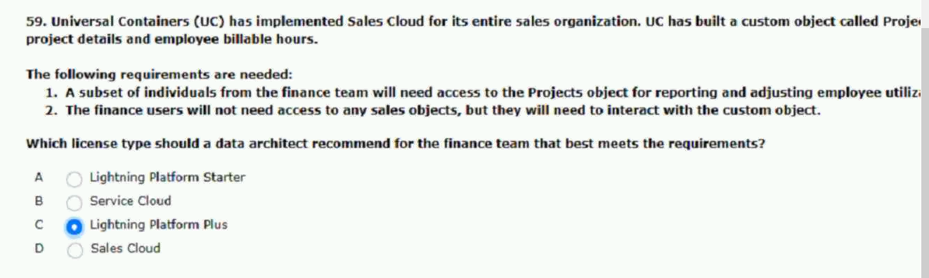
120.and failures during the process.
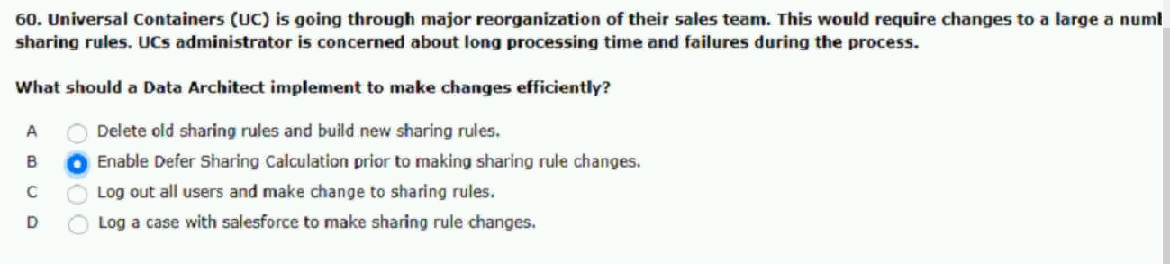
121.case of outage.
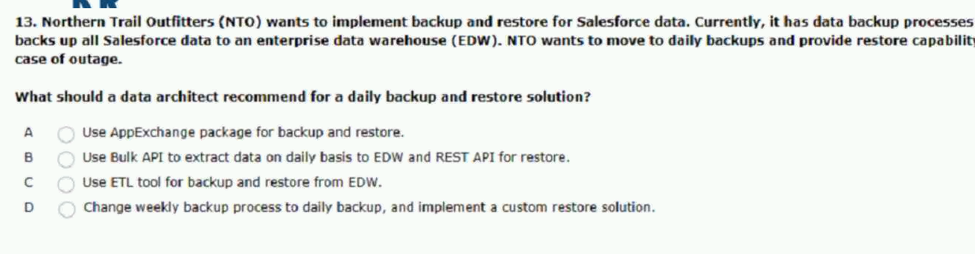
ans:c
users are complaining that the report will regularly timeout.
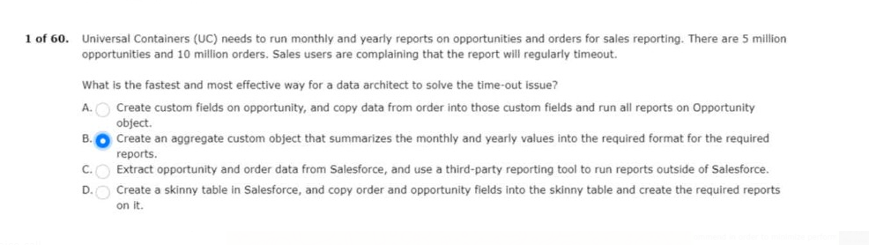

monitor and measure the data that is input in to the system.
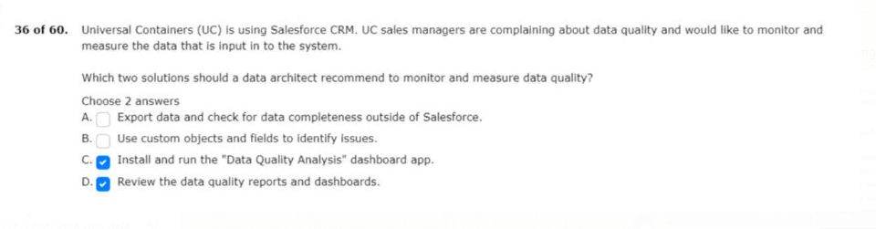

1.system into sales cloud with the following requirements.
